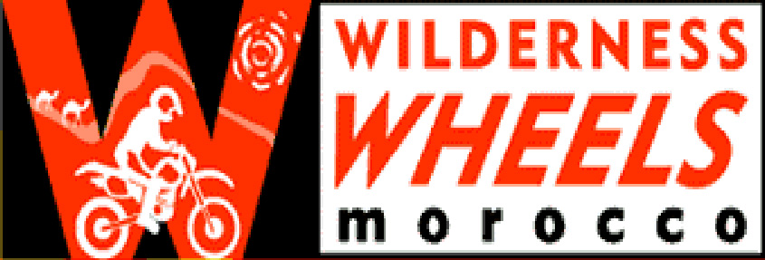

Wilderness Wheels S.A.R.L.
No 61, Hay Al-Qods, Ouarzazate, Maroc

Name & Surname______________________________ Contact Name & Telephone in case of emergency

Address ______________________________________ ___________________________________________

______________________________________________ ___________________________________________

Tel ___________________________________________

Assumption of Risk and Release of Liability

I, the undersigned, my heirs, legal representatives or successors, hereby release Wilderness Wheels, its owners, employees, suppliers and affiliates, from any and all claims, debts, actions and liability which may arise, directly or indirectly, from participating in any or all aspects of offered tour or rental, or for any loss, injury, death, damages to or in respect to any person or property however caused or arising. No liability shall be incurred by Wilderness Wheels for delay, loss, damage, or injury to person or property while a participant is using the facilities of taxis, buses or other transportation line, or during a trip. We strongly recommend travel insurance covering loss, damage or theft of luggage and personal belongings; personal injury; accidents and illness; and repatriation.
I fully understand the risks in motorcycling, the booking and cancellation policy, and accept the terms and conditions which apply to my reservation.

Wilderness Wheels Damage Policy, with or without guide

Included in the rental fee, Wilderness Wheels will furnish one Honda XR250R or XR400R or XR650R or CRF450X or KTM400 EXC motorcycle to each client. If during the course of the tour, the client’s motorcycle cannot be used due to damage caused by an accident or negligent use, the client is still required to return the machine to the WILDERNESS WHEELS agency of departure. Collection of the machine can be arranged at a cost of 5Dh/km (surfaced road) 10Dh/km (piste). A second motorcycle will not be furnished to the client, unless upon request, and then, upon signing a second rental contract. The cost of the clients’ return, with their personal effects, will be the sole responsibility of the client. Wilderness Wheels will not be held liable for such costs.

The Client hereby agrees to assume all responsibility for costs incurred due to damage to the motorcycles and riding gear which result from accidents and/or negligent and careless riding or use. In the event of such aforementioned damage, the cost of this will be assessed and deducted from the client’s deposit. The value of the damaged parts or gear will be determined by the value of that particular item on www.bikebandit.com or www.foxracing.com plus 30% for shipping and customs.

It is strongly advised to purchase fuel from licensed filling stations only. Purchase of inferior quality fuel in rural areas can cause serious engine damage, whose repair will be charged to the client.

I, the undersigned, understand fully the above terms and conditions, and accept to abide by these rules.

Signature ____________________________ Representative of Wilderness Wheels

Date _________________________________ ___________________________________

Model & Immatriculation of bike provided : _____________________________________________________

